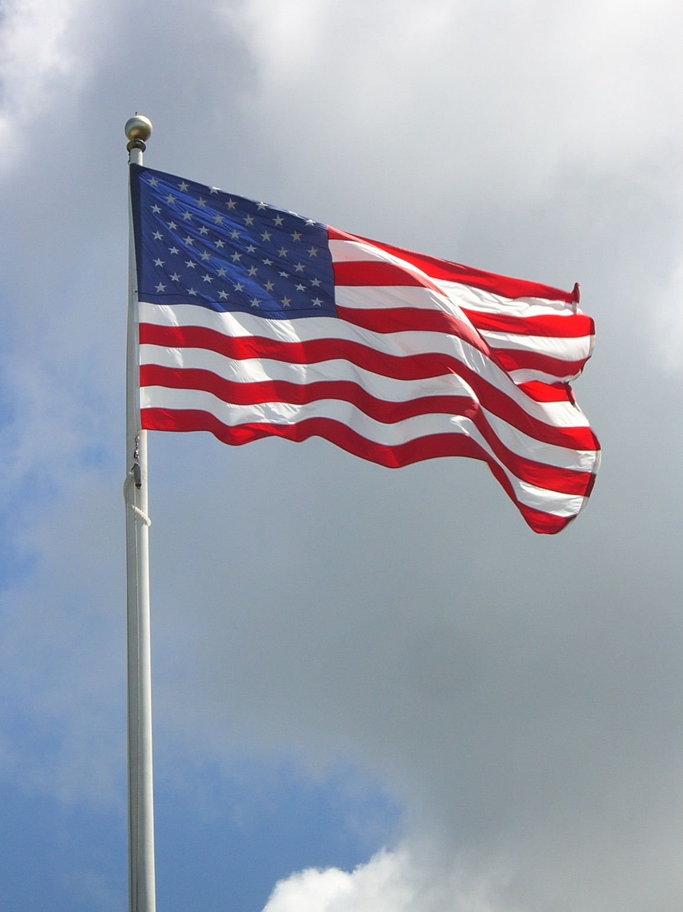

Join us for a celebration to honor veterans

who have served for our country and receive

Information about “New” housing benefits.

Wednesday, November 10, 2021

Friendship Circle Senior Center

1515 Lansdowne Ave

Darby, PA 19023

Starting at 9:00

Register:

In person at front desk 610-237-6222

Or

Call Roberta at 484-534-2033

Veterans Recognition

Friendship Circle Senior Center